During the U.S. Women's Open on USA Network 6/4-6/6, local advertising inventory was unavailable and no local breaks aired during tournament coverage. As a result, we have developed a make good schedule to address impacted inventory. Below is the updated make goods on USA for the U.S. Women’s Open, with the first make good landing on 6/15/2026.
USA
U.S. WOMEN’S OPEN MAKE GOODS
June-August 2026

U.S. Women’s Open Make Goods
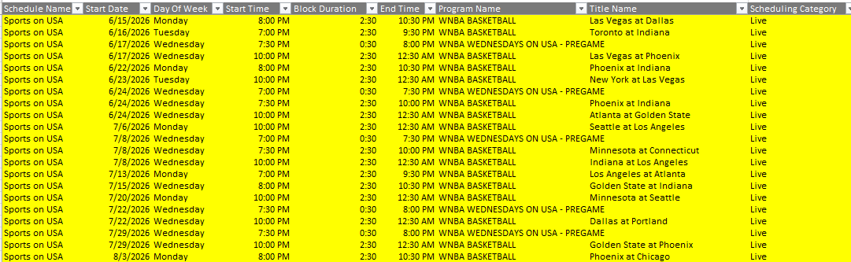
All times Eastern. You can also find this information on our affiliate website. https://versantmediatools.com/tech-info/

Please contact Moshe.Bennett@versantmedia.com and Kaitlyn.marer@versantmedia.com with any questions. Thank you!

